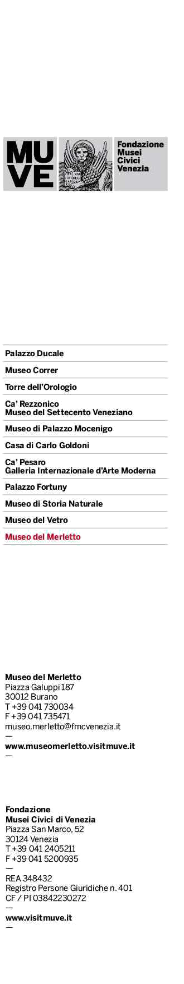

“LACE FOR VENICE” 2024 COMPETITION

DESCRIPTION OF THE ITEM

NAME OF ARTIST__________________________________________________

SURNAME OF ARTIST______________________________________________

TITLE OF THE WORK_____________________________________________

SECTION (needle or bobbin lace)______________________________________

SUBSECTION (traditional or contemporary)____________________________

DESCRIPTION OF THE WORK____________________________________

_______________________________________________________________

_______________________________________________________________

_______________________________________________________________

_______________________________________________________________

_______________________________________________________________

The Fondazione Musei Civici di Venezia accepts no obligation to publicise/use data collected for the competition.
The provision of data in the attached registration form and in the profiles of work is obligatory; failure to provide it may prevent entry in the competition. Data collected will not be disclosed to third parties, except in the event of subsequent use of all materials sent for their potential display, including the names of the artists, for the data controller’s organisational purposes. Data will not be retained beyond the duration of the competition, and may be deleted.
The data controller is the Fondazione Musei Civici di Venezia, with offices at San Marco 52, Venice, in the person of the pro tempore President of the foundation. All data subjects hold the rights stipulated in article 7 of law 196 of 30/06/2003, which may be exercised by contacting the data controller at the email address museo.merletto@fmcvenezia.it

Please email any comments or suggestions to museo.merletto@fmcvenezia.it.

PLACE AND DATE___________________________________________________

SIGNATURE________________________________________________________

